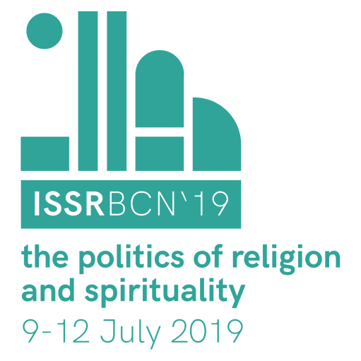

Barcelona, 9-12 Juliol 2019

The Politics of Religion and Spirituality

Introduction

This report includes basic information on the preparation, organization and budget of the 2019 ISSR Conference. Please, don’t hesitate to ask for more details.

Background

We did not present a candidature to organise the 2019 ISSR Conference. However, Mar Griera was approached by the current ISSR president, Jörg Stolz, in April 2018 about the possibility of organising the 35th Conference in Barcelona.

Between May and June 2018, Mar Griera proposed the idea of organising the Conference to ISOR members, and it was approved in the internal assembly. We prepared the dossier with two possibilities: a) organising the conference at the Autonomous University of Barcelona (our university); b) organising the conference in the city centre of Barcelona, and with the collaboration of the University of Barcelona. This second option, which was a bit more expensive, was accepted by the ISSR Council in May 2018.

Mar Griera proposed to Manuel Delgado, professor of anthropology of religion at the University of Barcelona, the possibility of collaborating in the organisation of this event to facilitate the bureaucratic process and to strengthen the local committee. He accepted and joined the local team, together with his colleagues from the GRECS research group. From then on, we have been organising the conference together, and we also have involved other local institutions and local scholars.

During the following months, we met every 15 days to talk about the logistics of the conference, and to distribute tasks. Over the past month, we met every week. Initially, ISOR hired Anna Clot to deal with the logistics. When Anna started a postdoc position in February, she was replaced by Victor Albert. Mar Griera was on sick leave for several months but the members of the local team –and especially Romina Martínez, Rosa Martínez, Avi Astor, Anna Clot, and Victor Albert- took care of everything.

Locations and main activities

It is difficult to find an auditorium for 400 people in Barcelona. We initially explored the idea of doing the conference in a convention centre near the university but this was too expensive. After exploring different options –in terms of availability and price- we decided to opt for the current combination, which includes the CCCB, the University of Barcelona, and other local (and nearby) institutions. The CCCB has a very good reputation for this type of event, and the combination of UB + CCCB was already used by the International Sociological Association Forum in 2010.

The conference will take place in the following locations:

- CCCB: Four plenaries and the ISSR general assembly
- University of Barcelona (on the same street as the CCCB):
  - Over 100 parallel sessions
  - Registration and book exhibition (2nd floor)

The local team has organised several social and cultural activities that will take place in other venues:

- Filmoteca de Catalunya: Film exhibition and debate with Irene Becci and Camil Ungureanu
- CCCB: Roundtable on Islamophobia (in Spanish and Catalan)
- Universitat Blanquerna_Ramon Llull: Workshop on visual ethnography
- MACBA (Musem of Contemporary Art): Film exhibition and debate with the author Roger Canals
- Central neighbourhoods and Collserola Nature Reserve: Walking tours and wine tour (sold out).

In addition, we have organised an opening cocktail (CCCB) and a Gala Dinner. Gala Dinner will be held in a lovely restaurant in a prime location by the sea. We had originally planned for it to be at another restaurant, but they changed their terms at the last minute.

Some general numbers

- 496 persons registered (449 have paid, the rest are pending).
- 236 reduced fee
- 167 normal fee
- 53 non-members
- 40 no fee (members of local committee, volunteers, speakers…).

The number of persons registered exceeded our initial previsions. Initial approximations were formulated on the basis of previous conferences (and membership), but they turned out to be underestimations. In this conference, the number of people registered under the category “reduced fee” has been higher than expected, which has consequences for the final budget.

Local committee and institutions involved

Mar Griera and Manuel Delgado have acted as local co-chairs. They have been assisted by a local coordination team that includes Victor Albert, Anna Clot, Rosa Martínez, Romina Martínez, Avi Astor and Alberto López Bargados, as well as several other scholars affiliated with ISOR and the GRECS research group.

A local scientific committee was initially composed to strengthen the links with scholars working in the field of religion. Several local institutions have been involved, including the Associació Catalana de Sociologia, the Institut Català d’Antrpologia, the MACBA, the CCCB, Universitat Ramon Lllull-Blanquerna, the Filmoteca de Catalunya and the Institut Europeu de la Mediterrània.

Opening Panel

It was difficult to design the opening panel. A previous ISSR conference had already been organised in Santiago in 2009, and some Spanish scholars had participated in that conference’s opening panel. We decided that we did not want to repeat with the same people and, for this reason, we included two scholars currently working in Barcelona (Avi Astor –from US- and Roger Sansi –from Barcelona), and two scholars that do not currently work in Barcelona but have closed relations with the city (Julia Martínez-Ariño –originally from Zaragoza and now in Groningen- and Anna Fedele –who did her PhD at the UAB and is still involved in local research groups but is now based in Italy).

The participation of public officials in the inauguration was a condition for getting funding for the cocktail.

Funding

We have followed two main funding strategies:
- We asked for a discount on the prices for renting spaces at the two main institutions involved – the CCCB and University of Barcelona. Thanks to our collaboration with Manuel Delgado and his team, we got a discount of 50% on renting rooms at the university. And thanks to the historical relations between ISOR and the CCCB, we were offered a 20% discount, plus the inclusion of additional facilities.

- Funding applications

We have successfully attained the following funds:
  - Ajuntament de Barcelona: 5000 euros.
  - Universitat de Barcelona: 3000 euros
  - Universitat Autònoma de Barcelona: 500 euros
  - Generalitat de Catalunya: 5000 euros

We are still waiting for the result of two other applications:
  - Diputació de Barcelona
  - Institut d’Estudis Catalans

We were unsuccessful in our solicitation of funds from two foundations: Banc de Sabadell and Pluralismo y Convivencia.

Other aspects and future suggestions

Our interaction and organisation with the ISSR council has been very fruitful. The visit of Veronique Atglas and Oliver Servais to Barcelona in February was particularly helpful in this regard. It facilitated communication and decision-making on several issues.

We consider the requirement of membership as a condition for submitting a paper as positive since it strengthens the commitment of applicants.

The organisation of the publishers’ exhibition has been (unexpectedly) difficult. It would be useful to rethink how to proceed with this for the next conference.

In the future, it might be useful to specify on the website who does what regarding registration, programming, and so on to make things clearer for participants. This might help to avoid having people ask the same question to several different people. It can also be useful to concentrate all the decisions regarding the program (composition, organisation, changes, edition…) to one person.

The relationship with Bérénice has been excellent and very easy. It is important to underline that she has been key to the organisation of the Conference.

